# Section 3.1: Defining the Derivative

## Tangent Lines

Recall: The slope of a secant line to a function at a point $(a, f\left(a\right))$ is used to estimate the rate of change, or the rate at which one variable changes in relation to another variable. The slope of the secant line can be found by finding two points, such as $(a, f\left(a\right))$ and $(x, f\left(x\right))$ and using the difference quotient (slope formula).

Let $f$ be a function defined on an interval $I$ containing $a$. If $x≠a$ is in $I$, then

$Q=\frac{f\left(x\right)-f(a)}{x-a}$

is a **difference quotient**.

Also, if $h≠0$ is chosen so that $a+h$ is in $I$, then

$Q=\frac{f\left(a+h\right)-f(a)}{h}$

Is a difference quotient with increment $h$.

We can calculate the slope of a secant line two ways. The choice of method usually depends on ease of calculation.

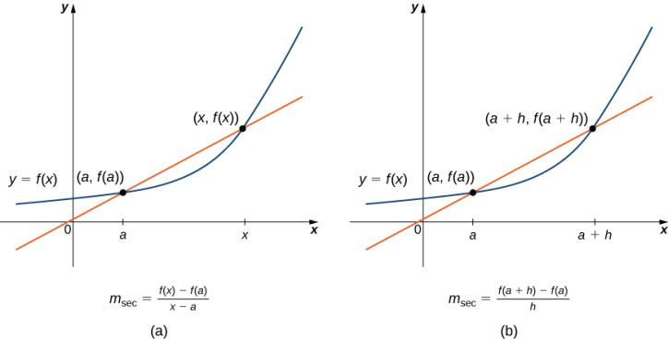

As the values of $x$ approach $a$, the slopes of the secant lines provide better estimates of the rate of change of the function at $a$. Furthermore, the secant lines themselves approach the tangent line to the function at $a$, which represents the limit of the secant lines.

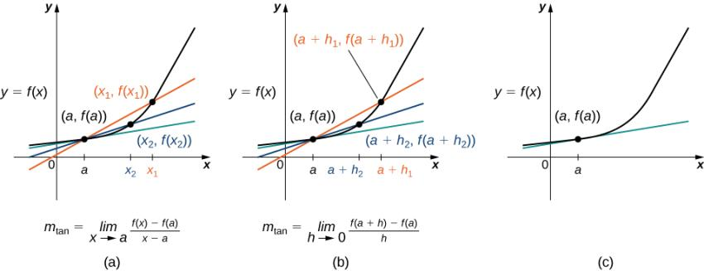

The secant lines approach the tangent line (shown in green) as the second point approaches the first, by letting $x$ approach $a$ or $h$ approach $0$.

Let $f(x)$ be a function defined in an open interval containing $a$. The tangent line to $f(x)$ at $a$ is the line passing through the point $(a, f\left(a\right))$ having slope

$m_{tan}=\lim_{x→a}{\frac{f\left(x\right)-f\left(a\right)}{x-a}}$

provided this limit exists.

Equivalently, we may define the tangent line to $f(x)$ at $a$ to be the line passing through the point $(a, f\left(a\right))$ having slope

$m_{tan}=\lim_{h→0}{\frac{f\left(a+h\right)-f\left(a\right)}{h}}$

provided this limit exists.

Again, the choice of which definition to use will depend on the setting.

Media: Watch this [video](https://youtu.be/0zExhHh7_Ic) example on finding the slope of the secant line.

Media: Watch this [video](https://youtu.be/TBJrsYLRod8) example on finding the slope of the tangent line using the definition.

Examples

1. Given $f\left(x\right)=\sqrt{x-9}; x_{1}=10; x_{2}=13$, find the slope of the secant line between the values $x_{1}$ and $x_{2}$.
2. Find the equation of the line tangent to the graph of $f\left(x\right)=x^{2}$ at $x=3$
3. using the definition $m_{tan}=\lim_{x→a}{\frac{f\left(x\right)-f\left(a\right)}{x-a}}$
4. using the definition $m_{tan}=\lim_{h→0}{\frac{f\left(a+h\right)-f\left(a\right)}{h}}$

## The Derivative of a Function at a Point

This type of limit occurs in many applications across many disciplines. These applications include velocity and acceleration in physics, marginal profit functions in business, and growth rates in biology. This limit is known as the **derivative** and the process of finding the derivative is called **differentiation.**

Let $f(x)$ be a function defined in an open interval containing $a$. The derivative of the function $f(x)$ at $a$, denoted by $f^{'}(a)$, is defined by

$f^{'}\left(a\right)=\lim_{x→a}{\frac{f\left(x\right)-f(a)}{x-a}}$

provided this limit exists.

Alternatively, the derivative of $f(x)$ at $a$ can also be defined as

$f^{'}\left(a\right)=\lim_{h→0}{\frac{f\left(a+h\right)-f(a)}{h}}$.

Media: Watch this [video](https://youtu.be/36XJchP5NOw) example on using the two definitions of the derivative.

Examples

1. For $f\left(x\right)=3x^{2}-4x+1$, find $f^{'}(2)$
   1. by using $f^{'}\left(a\right)=\lim_{x→a}{\frac{f\left(x\right)-f(a)}{x-a}}$
   2. by using $f^{'}\left(a\right)=\lim_{h→0}{\frac{f\left(a+h\right)-f(a)}{h}}$

Media: Watch this [video](https://youtu.be/9ZYNJN_yMMk) example on finding the derivative using the definition.

1. For $f\left(x\right)=5x+4$, find $f^{'}(a)$ when $a=-1$.

Media: Watch this [video](https://youtu.be/rHCpw9a0Ork) example on estimating limits from a graph.

Media: Watch this [video](https://youtu.be/jvYZNp5myXg) example on estimating limits from a table.

1. Use the following graph to evaluate $f^{'}\left(1\right)$ and $f^{'}\left(6\right)$.

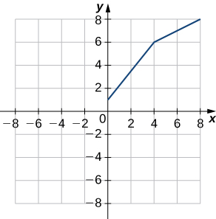

## Velocities and Rates of Change

If $s(t)$ is the position of an object moving along a coordinate axis, the average velocity of the object over a time interval $[a,t]$ if $t>a$ or $[t,a]$ if $t<a$ is given by the difference quotient

$v_{average}=\frac{s\left(t\right)-s(a)}{t-a}$.

As the values of $t$ approach $a$, the values of $v_{average}$ approach the value called the instantaneous velocity at $a$, denoted $v(a)$ and is given by

$v\left(a\right)=s^{'}\left(a\right)=\lim_{t→a}{\frac{s\left(t\right)-s(a)}{t-a}}$.

To better understand the relationship between average velocity and instantaneous velocity, see the figure below.

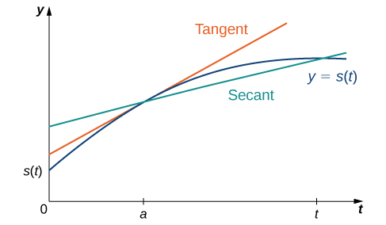

The slope of the secant line is the average velocity over the interval $[a,t]$. The slope of the tangent line is the instantaneous velocity. The equation $f^{'}\left(a\right)=\lim_{x→a}{\frac{f\left(x\right)-f(a)}{x-a}}$ can be used to calculate the instantaneous velocity at $x=a$ or we can estimate the velocity of a moving object using a table of values.

Media: Watch this [video](https://youtu.be/g5PpEM7B4uA) example on finding velocity using limits.

Media: Watch this [video](https://youtu.be/jvYZNp5myXg) example on estimating rates of change.

Media: Watch this [video](https://youtu.be/0cuuzRy4Gjw) example on finding instantaneous rate of change.

Examples

1. A lead weight on a spring is oscillating up and down. Its position at time $t$ with respect to a fixed horizontal line is given by $s\left(t\right)=\sin{t}$ as shown in the figure below. Use a table of values to estimate $v(0)$.

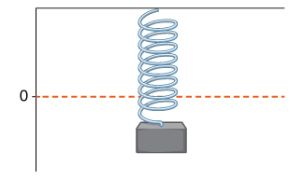

1. A rock is dropped from a height of $64$ feet. Its height above ground at time $t$ seconds later is given by $s\left(t\right)=-16t^{2}+64, 0≤t≤2$. Find its instantaneous velocity $1$ second after it is dropped, using $f^{'}\left(a\right)=\lim_{x→a}{\frac{f\left(x\right)-f(a)}{x-a}}$.

The **instantaneous rate of change** of a function $f(x)$ at a value $a$ is its derivative $f^{'}(a)$.

Media: Watch this [video](https://youtu.be/g5PpEM7B4uA) example on position and velocity using definitions.

Examples

1. Reaching top speed of $270.49$ mph, the Hennessey Venom GT is one of the fastest cars in the world. In tests it went from $0$ to $60$ mph in $3.05$ seconds, from $0$ to $100$ mph in $5.88$ seconds, from $0$ to $200$ mph in $14.51$ seconds, and from $0$ to $229.9$ mph in $19.96$ seconds. Use this data to show a conclusion about the rate of change of velocity (that is, its acceleration) as it approaches $229.9$ mph. Does the rate at which the car is accelerating appear to be increasing, decreasing, or constant?
2. A toy company can sell $x$ electronic gaming systems at a price of $p=-0.01x+400$ dollars per gaming system. The cost of manufacturing $x$ systems is given by $C\left(x\right)=100x+10,000$ dollars. Find the rate of change of profit when $10,000$ games are produced. Should the toy company increase or decrease production?
3. Two vehicles start out traveling side by side along a straight road. Their position functions, shown in the graph below, are given by $s=f(t)$ and $s=g(t)$, where $s$ is measured in feet and $t$ is measured in seconds.

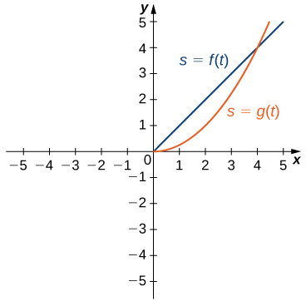

1. Which vehicle has traveled farther at $t=2$ seconds?
2. What is the approximate velocity of each vehicle at $t=3$ seconds?
3. Which vehicle is traveling faster at $t=4$ seconds?
4. What is true about the positions of the vehicles at $t=4$ seconds?